MAASAI HEALTH SYSTEMS

16714 91st Ave. E.
Puyallup, WA 98375
a tax exempt 501 (c)(3) charity
NEWSLETTER # 51 August 2017

I have been here at Selian for three months now on this second trip to Arusha, Tanzania. I can see changes (improvements) in two areas. One is in me. The first six months here (last time) were, essentially, my internship in tropical African medicine. For the first time in my medical career, I had to seriously consider a diagnosis like neuroschistosomiasis, malaria or cryptococcal meningitis. I had read of those diseases, but had never seen them. I am now familiar with many of the unique diseases here. We do not have the luxury of extensive laboratory and x-rays studies so I had to get used to dealing with diagnostic uncertainly. It is still disconcerting, but I did get used to treating critically ill patients without ever know what I was really treating. The last thing was that they treat familiar diseases differently, often using medications that we no longer use in the USA. I have an advantage over the trainees I supervise. I can recall using the older medications when I was an intern myself which was .....well, to tell the truth, before the current trainees were born. Below are the New Zealand, American and Tanzanian trainees I work with.
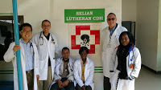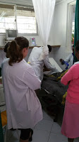
The other place I see improvement is in the hospital itself. The lab has added some very important labs tests so my uncertainty is somewhat reduced. They are also talking about ways to add doing cultures in the future. Yay!! They have opened an Intensive Care Unit. It is pretty basic, but it is a start. Above on the right is a picture of one of my patients in the ICU. The patient is intentionally obscured for privacy reasons. The white thing hanging down from the ceiling is mosquito netting which is critical for malaria prevention.
I didn't take pictures, but the sinks on the wards are all functioning again. None of them worked last time. The rubberized surface on the old mattresses were very cracked which is a big problem for cleanliness and infection control. They are progressively replacing them.
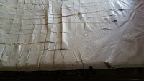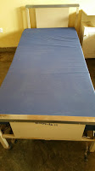
I thought the two pictures below were interesting. The one on the left shows how Maasai like to wrap up in their blankets like a cocoon to sleep. The one on the right shows two family members. It is "winter" here and furnaces aren't a part of any building I have ever been in here so the hospital interior goes below 60 degrees at night which is "freezing" for Tanzanians. The other thing about this photo is the importance of family who do much of the care of the patients including providing the food. The hospital doesn't provide food service.
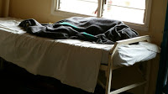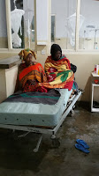
Below is the reason we are asking for donations for a new electrical generator for Selian. A hospital in Denver replaced their outdated digital X-ray machine and donated the old machine to Selian. In the USA, X-rays are viewed on a computer monitor; X-ray films are a rarity now. This is a wonderful upgrade for Selian, but the new problem is that the new X-ray unit needs more electricity than is produced by the old generator. When the city electricity is out, which is often, the digital equipment doesn't work and they have to go back to the less clear film technique. We hope to raise $30,000 this year to replace the generator and are only halfway there. Please consider helping with this worthy cause.
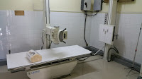 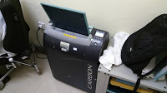 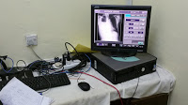
I thank you in advance for your support.
Don Rowberg, president, Maasai Health Systems.

