MAASAI HEALTH SYSTEMS
16714 91st Ave. E.
Puyallup, WA 98375
a tax exempt 501 (c)(3) charity
NEWSLETTER # 55 March, 2020

HELP US SOLVE A MYSTERY
We now have a website at http://maasaihealth.com. Most non-profit organizations use an ".org" address. We wanted to do the same, but discovered that maasaihealth.org is already taken. That address does not have an associated web page. We don't know who the owner is other than that they claim to be from Washington state and be a friend of MHS. If you have any knowledge about this, please let me know by email through the contact section of our website.
THE NEW WASHER AND DRYER HAVE ARRIVED
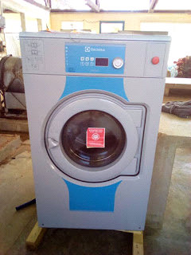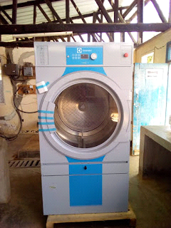
Here they are! The new commercial-size washer and dryer that we bought for Selian Hospital this year are pictured above. They have now been installed and are in operation. There was also an unexpected tax bill on the electricity generator that we paid. Taxing a non-profit hospital for purchases is a new thing with the current Tanzanian national administration. We have been assured there is no tax on the washer and dryer or the next project.

NEW PROJECTS
We have been asked to buy a number of small devices that are needed for Selian Hospital rather than a single large project like the washer and dryer. We will purchase items as we get the funds to buy them. Their list includes infant incubator, phototherapy lamp, infant CPAP, sterilizer and bacteria incubator for the lab, EKG machine, and a sterilizer for dental tools.

EKG MACHINE
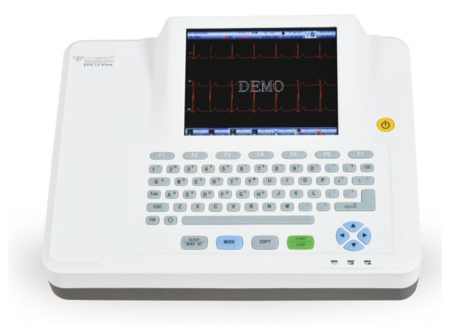
We have already purchased an EKG machine. It is on order but hasn't arrived yet. Diabetes and hypertension are common diseases in Tanzania so there is most likely heart disease as well. Selian hasn't had a functioning EKG machine for over a year. The lab can't do the blood tests to confirm a heart attack, so an EKG machine will be crucial to diagnosing what is probably unrecognized heart disease.

NEONATAL ICU EQUIPMENT
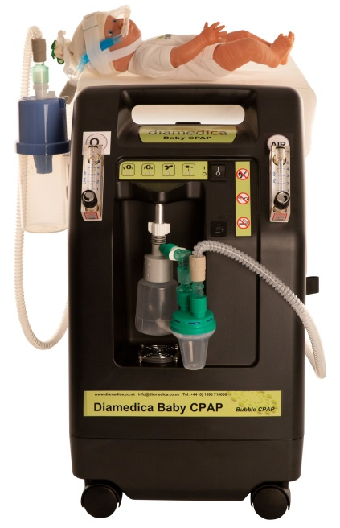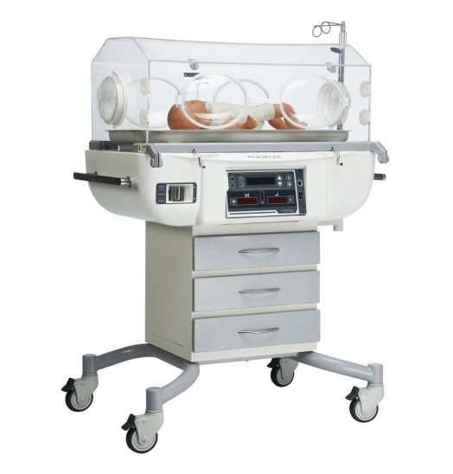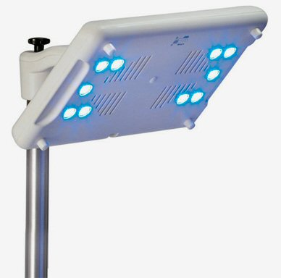

The back story to this is that Selian Hospital has opened up a Neonatal ICU (NICU). They have 6-8 newborn sick babies on a typical day. This is pretty exciting stuff. It is now the second NICU in the region - the other being at our sister hospital in downtown Arusha. The three items pictured left to right are a neonatal bubble CPAP, an incubator, and a phototherapy lamp. The bubble CPAP provides respiratory support for premature babies with immature lungs that need extra help supporting lung function until the lungs "grow up." The World Health Organization reports that premature birth is now the leading cause of death globally in newborns, usually because of immature lungs. The neonatal incubator provides a safe, warm environment for those babies that need that extra protection. The third item is a phototherapy lamp which is already purchased. Long ago in a hospital newborn nursery, somebody noticed that the jaundiced babies by the windows in the nursery got better faster than the others. This is how we discovered that light helps clear up jaundice, hence phototherapy for jaundice.

BACTERIOLOGY EQUIPMENT
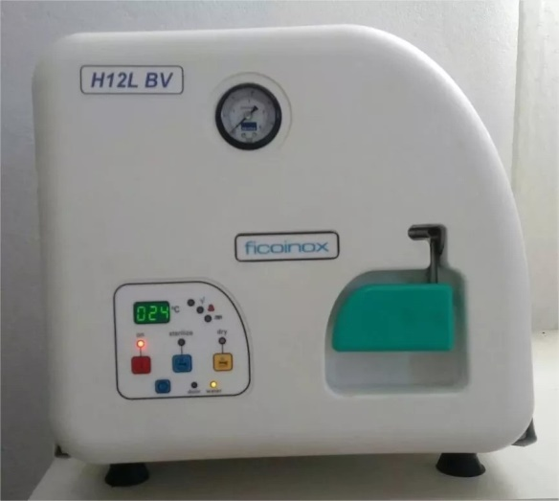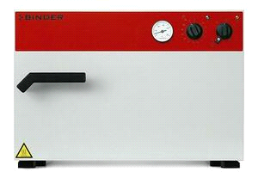
Selian has three additional items on their list. The first (on the left above) is an autoclave for the dental clinic to use to sterilize their instruments between patients. The last two items will be fantastic additions to the laboratory. These are an incubator for growing bacteria (already purchased) and a hot air oven. The oven is a sterilizer for the soon-to-be microbiology section of the lab. The incubator will allow us to grow and identify the bacteria causing infections. Up to now, we have had to make guesses as to which antibiotics to use since we didn't have the capacity to identify bacteria and the best drugs to use. On the right is a single image. The Binder Company sterilizer and the Binder incubator doors look the same so I just inserted one picture. The difference is the sterilizer is built for temperatures that are 200 degrees hotter even though the doors look the same.
NEW WEBSITE, DONATE BY CHECK OR THROUGH PAYPAL
I thank you for your past support and invite your joining in on these valuable purchases. Checks can be mailed to the address at the top of the newsletter. We have also added PayPal as an option for donations by you tech-savvy people. Even if you are not so savvy, you can use PayPal. It isn't hard. Go to our brand new Maasai Health Systems website that is still being developed, but is functional at http://maasaihealth.com.
In the website, click on the Donate item on the top menu. This takes you to the donation page which gives you the mailing address for checks and also offers a PayPal option by clicking on the gold-colored Donate button at the bottom of the page. This takes you to the PayPal site where you can use your PayPal account to make a donation or you can also use a credit card or debit card to make a donation through PayPal.

Don Rowberg
President
Maasai Health Systems

